SYM**✓**

**The Image-Based Self Diagnosis Web Application**

**User Manual**

**Contents**

**1. Getting Started...................................................................4**

1.1 Navigating to the application........................................4

**2. Homepage…………….............................................................7**

2.1 Watch a site demo………………………................................7

2.2 Beginning a Diagnosis………………………...........................8

**3. Upload Page......................................................................10**

3.1 Nearest Emergency Room button...............................12

**4. Advanced Prediction Page.................................................15**

4.1 Completing an “Advanced” Prediction……………..………15

4.2 Skipping the Advanced Prediction…………………..……….18

4.3 Nearest Emergency Room button…………………………….21

**5. Results Page…………………………………….……………………………..24**

5.1 Nearest Emergency Room button………………………….…26

**6. FAQ Page………………..…………………………...…………………………28**

6.1 Nearest Emergency Room button…………………………….29

**7. About Us Page………...........................................................31**

**8. Explanation of Sitewide Features…………………………………….33**

8.1 Site Navigation Bar…………………………………………………..33

8.2 Chatbot…………………………………………………………………….34

8.3 Site Footer and its Resources……………………………………36

**9. Contacting the Team……………………………………………………….39**

9.1 Emailing the Team……………………………………………………39

9.2 Social Media…………………………………………………………….40

**Getting Started**

Welcome to the official user guide for SymCheck, an image-based self-diagnosis web application!

Before we begin, please ensure that you have navigated to our cloud-hosted instance at: <http://www.symcheckapp.com>* or <https://symcheck.msjasmine.repl.co/>, or have the correct environment set up on your machine for running the SymCheck application via localhost, instructions for both of which can be found in the *SymCheck Installation Manual*.

After navigating to the application site, follow this guide for instructions on how to receive your own automatically-generated diagnosis information.

*Please note that after April 30, 2021, the symcheckapp.com site URL hosted via AWS will be deprecated due to cost concerns, but the complete SymCheck application can still be accessed via the second URL hosted on repl.it.

***Please also note that all images shown in this manual are for SAMPLE PURPOSES ONLY. What you see on your own machine may look slightly different.

**Navigating to the Application**

SymCheck works on various browsers hosted on your local computer, including Google Chrome, Mozilla Firefox, Internet Explorer, and Microsoft Edge. (Some bugs have been found in the use of Safari, thus our team would recommend using an alternate browser until this issue can be resolved.)

To start using the SymCheck application, simply start by navigating to: <https://symcheck.msjasmine.repl.co/>.

Conversely, should you choose to run the application via localhost, you can also start by running your Python virtual environment as set up via the *SymCheck Installation Manual* on your computer. Then navigate to the folder containing all the files for the SymCheck application, and run the Django server (after the secret code has been added to the settings.py file) via the command “python3 manage.py runserver” as demonstrated in the installation manual.

With your server up and running, open up your browser of choice and go to the localhost site outlined in your command line, i.e. <http://127.0.0.1:8000/>, or simply <http://localhost:8000>.

In either case, you should then see the following welcome page of the SymCheck application:

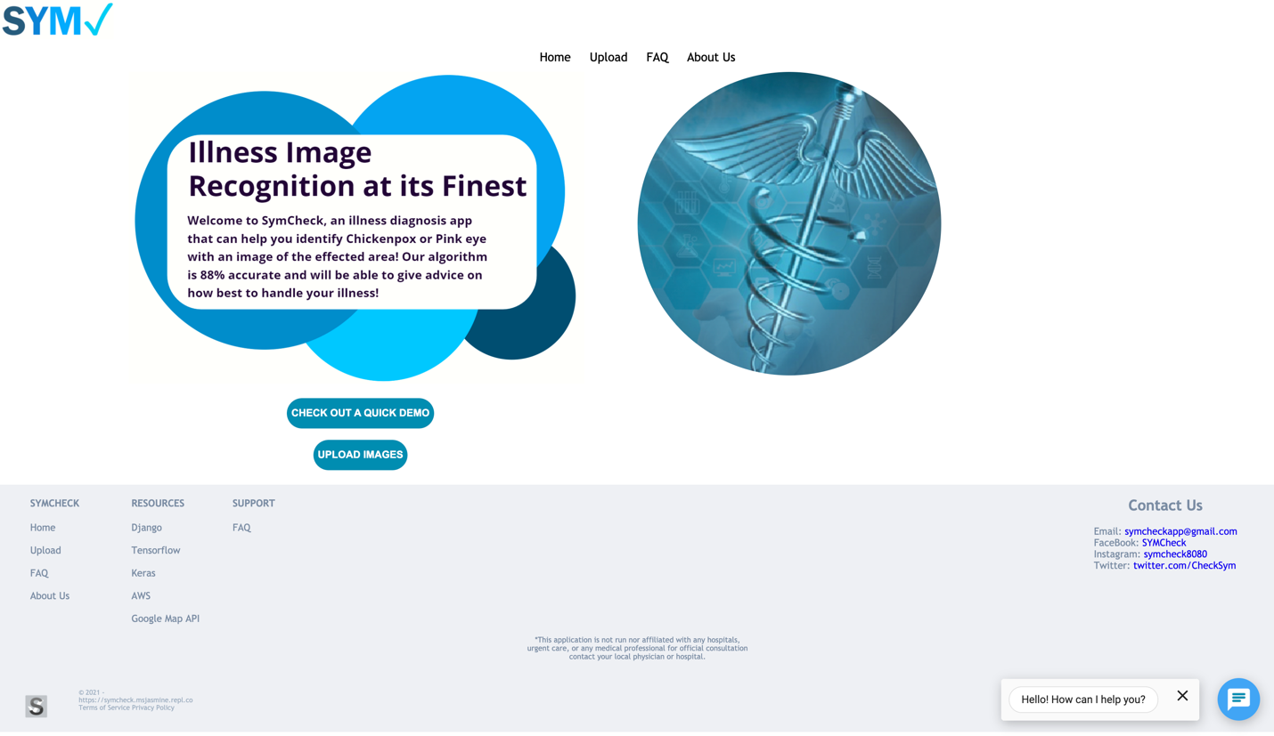

**Homepage**

**Watch a site demo**

For a quick overview of the main functionalities of the SymCheck website and all its features, as well as a walkthrough of navigating the website, click the “Check Out a Demo” button to watch a video led by one of the members of the SymCheck team:



**Beginning a Diagnosis**

To begin a diagnosis, simply click on the “Upload Images” button, or on the “Upload” tab of the top navigation bar to navigate to the application’s main image upload page as shown below:



Clicking said button or tab should then take you to the image upload page as shown on the following page:

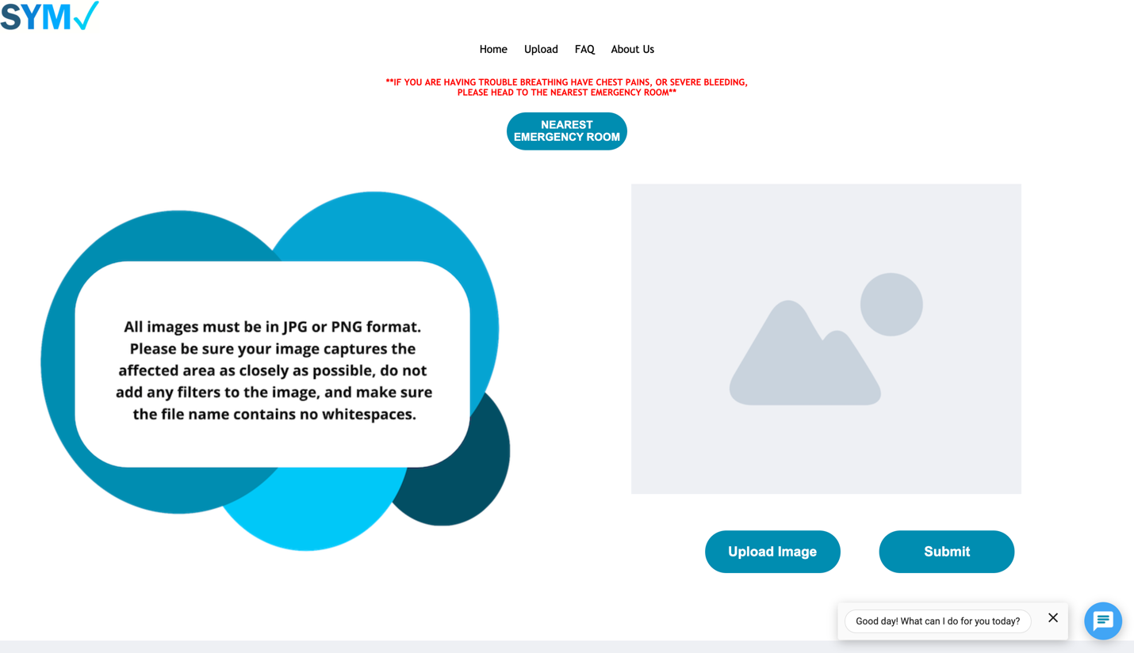

Great! Now we’re ready to upload an image of our illness!

**Upload Page**

We are now at the main image upload page of the SymCheck application. In order to upload an image of an illness, simply click on the “Upload Image” button as shown below:



This will open your computer’s local file space from which you will be able to choose your desired image file. **Acceptable formats include .png and .jpg/.jpeg**, as outlined in the instructions to the left of the upload field.

Once you have chosen an acceptable image, a preview of your image should be displayed above the “Upload Image” and “Submit” buttons, indicating that your image has been uploaded successfully. (Please note that the physical size of the preview may vary based on how large or small the image you have uploaded is.) Now click “Submit” to send your image to our backend machine-learning-based algorithm for classification while you are automatically navigated to the next page.

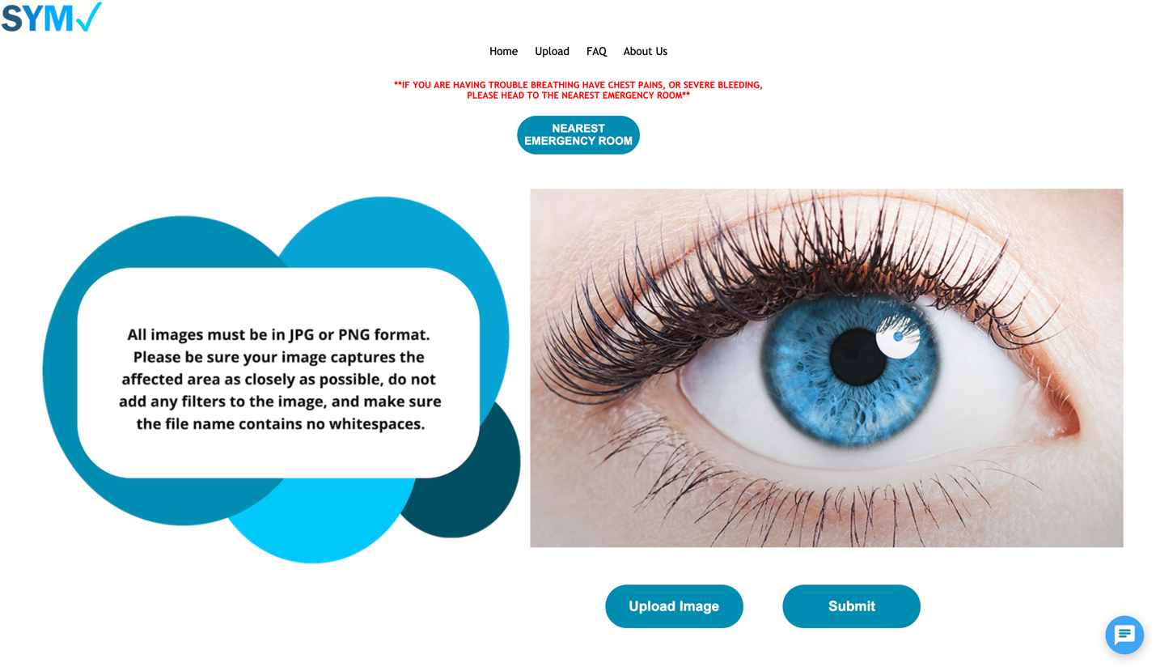 Clicking said “Submit” button should take you to the Advanced Prediction page shown on the following page:

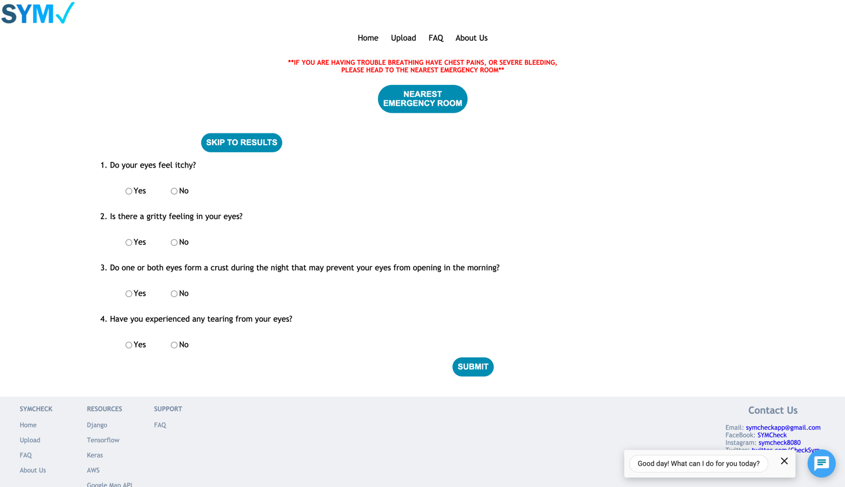

***Please note that the specific questions shown on this page will vary based on what type of illness/ailment is predicted by the backend algorithm from the image uploaded.

**Nearest Emergency Room button**

If at any time during this process you feel any of the symptoms outlined below, or deem your illness/ailment life threatening in any way, click on the “Nearest Emergency Room” as shown on the following page:



This will open a dynamic Google Maps window within the SymCheck application, showing you the locations of all healthcare facilities nearest you.

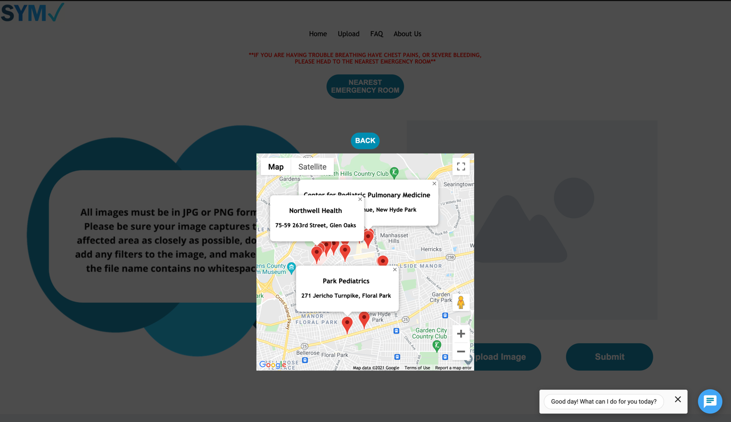

To close this map pop-up, simply press the “Back” button shown above the map itself.

**Advanced Prediction Page**

**Completing an “Advanced” Prediction**

Upon reaching the advanced prediction page, the application will pose a short series of yes or no questions for you to answer, based on a base/cursory prediction already made by the backend algorithm the SymCheck application. The answers made to the questions posed will then increase or decrease the final probability percentage, in order to provide you with a more accurate determination of whether or not you have a specific illness/ailment.



All questions must be completed to obtain an advanced, more accurate prediction percentage.

After answering yes or no to all the questions posed, click the “Submit” button to view your final results! (You MUST click “Submit” to send your answers to the backend algorithm of SymCheck and obtain your adjusted percentage prediction. Be sure not to click “Skip to Results” after filling out the questions as this will take you to the Results page and display your original, unadjusted prediction percentage without accounting for any of your answers.)

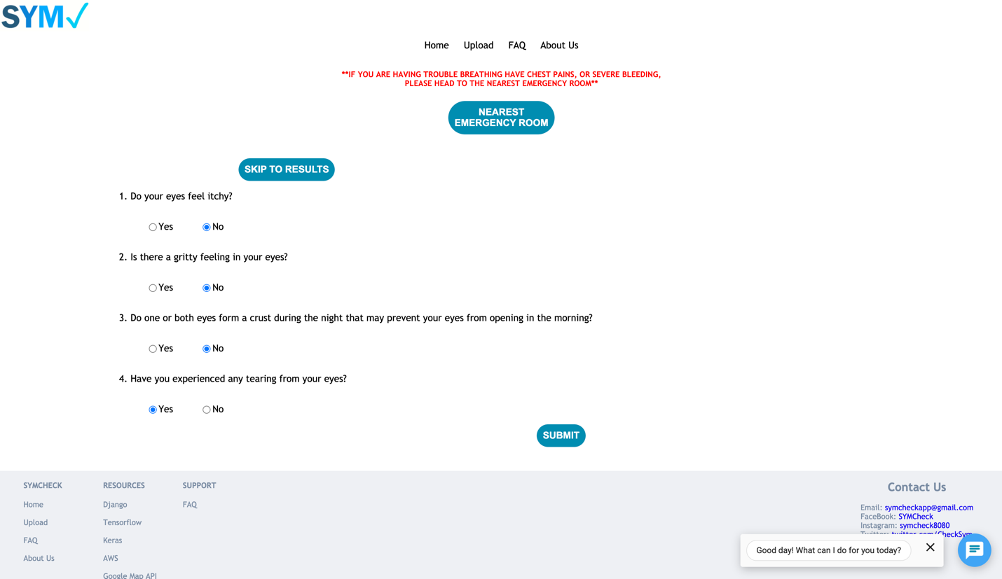

After completing all the advanced prediction questions and submitting your answers, you will be automatically taken to your final Results page, similar to that shown below:

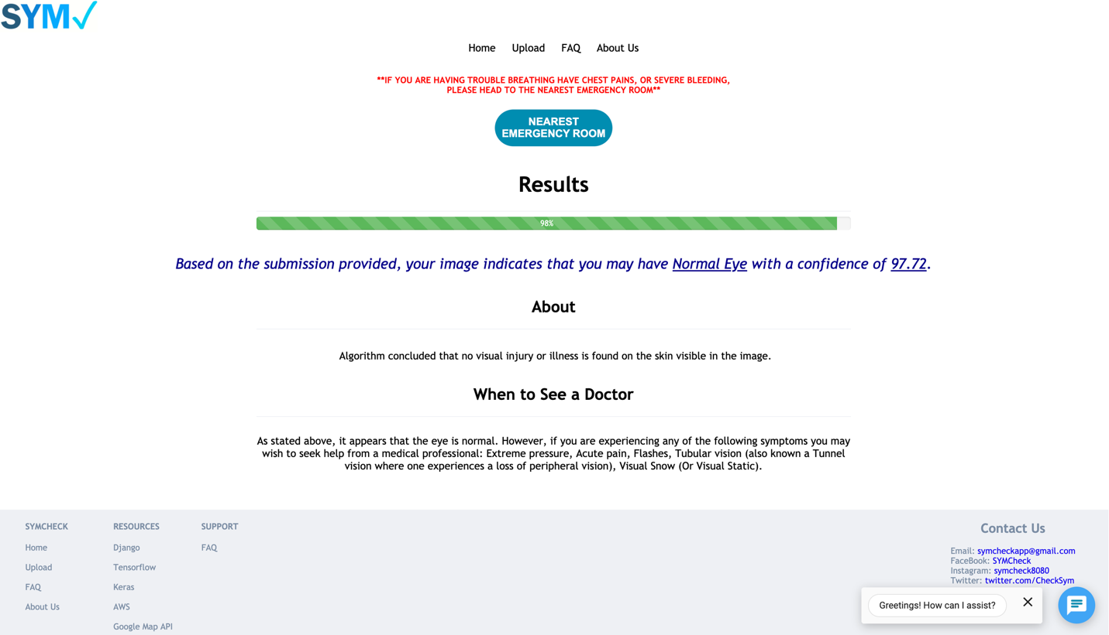

Congratulations on receiving your completed illness prediction from SymCheck!

Should you wish to start a new diagnosis, or at any time wish to restart your current diagnosis, simply click the “Upload” tab found in the top navigation bar as shown on the following page to return to the image upload and upload a new image. (Conversely, you can also return to the homepage in the same way and click “Upload Images” from there.)



**Skipping the “Advanced” Prediction**

Because SymCheck is all about saving its users time, and providing the highest possible degree of convenience, you also have the option to skip the task of answering the questions posed on the Advanced Prediction page by clicking the “Skip to Results” button as shown below. The questions themselves can only provide a *more* accurate determination of the final illness prediction, so, not to worry! A decision to skip said questions will *not* affect the cursory prediction made based solely on the image uploaded in any way.



After clicking “Skip to Results,” you will be taken to your final Results page, similar to that shown on the following page:

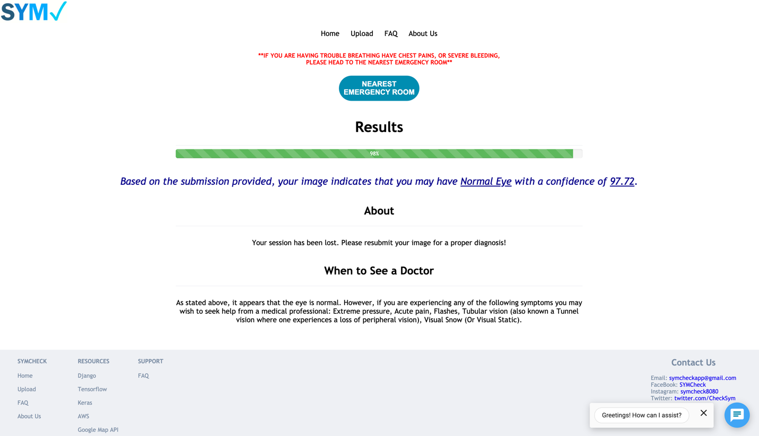

Congratulations on receiving your completed illness prediction from SymCheck!

Should you wish to start a new diagnosis, or at any time wish to restart your current diagnosis, simply click the “Upload” tab found in the top navigation bar as shown on the following page to return to the image upload and upload a new image. (Conversely, you can also return to the homepage in the same way and click “Upload Images” from there.)



**Nearest Emergency Room button**

If at any time during this process you feel any of the symptoms outlined below, or deem your illness/ailment life threatening in any way, click on the “Nearest Emergency Room” as shown on the following page:



This will open a dynamic Google Maps window within the SymCheck application, showing you the locations of all healthcare facilities nearest you.

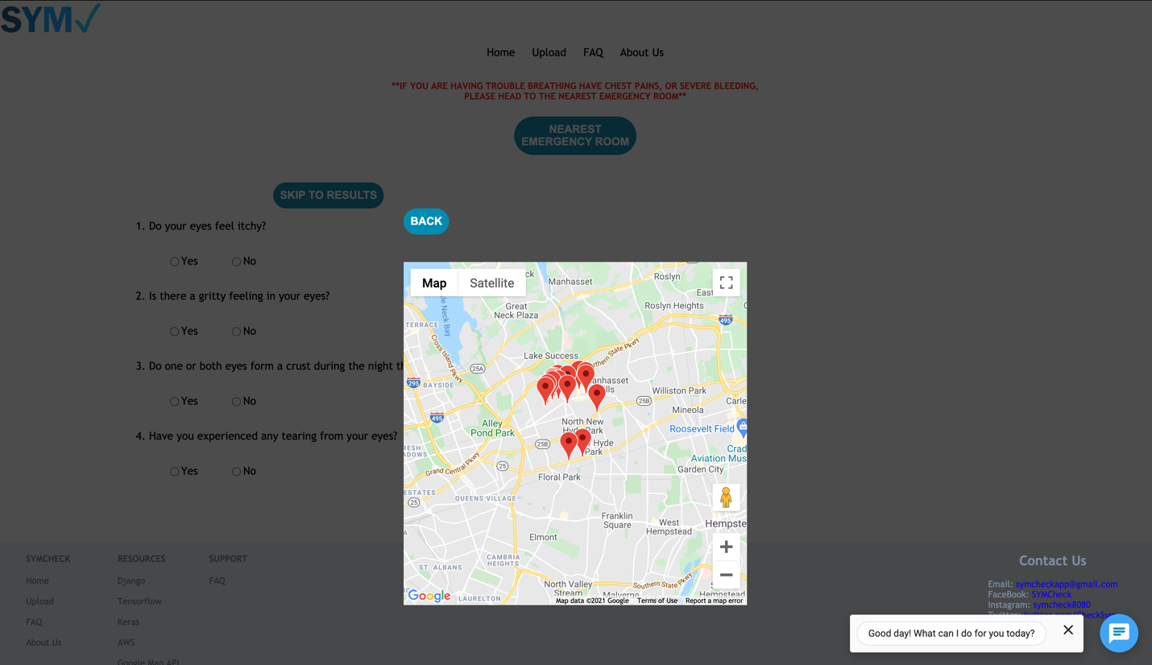

To close this map pop-up, simply press the “Back” button shown above the map itself.

**Results Page**

After uploading your image, and choosing to complete or opt out of an advanced prediction, you will reach your individual, illness-specific results page, a sample of which is shown below:



In the “Results” field, you will see what illness/ailment you are predicted to having based on our algorithm’s analysis of your uploaded image, as well as the percentage of probability of your having that specific illness based on your image, and any advanced questions answered. Above this prediction, you will also see a visual probability percentage bar showing how likely you are to have a certain illness—this bar is also color-coded to show how alarming a certain probability for a certain illness would be (i.e. green meaning there is no need for alarm, red meaning the illness and its percentage probability is cause for a little worry)

In the next, “About” field you will see a quick summary of that illness, as well as potential links to official health websites (i.e. the Center for Disease Control or CDC) for more information on said specific illness.

And lastly, the “When to See a Doctor Field” will provide a quick list of patient-specific conditions, and or symptoms that require further, sometimes immediate medical attention, and thus recommendations on under what circumstances you should seek an official diagnosis from a healthcare professional (remember, SymCheck provides only a cursory diagnosis to potentially save you time with home remedies, or save you a visit, but does NOT replace an official diagnosis from a healthcare professional).

**Nearest Emergency Room button**

If at any time whilst on this page you feel any of the symptoms outlined, or deem your illness/ailment life threatening in any way based on recommendations given, click on the “Nearest Emergency Room” as shown on the following page:



This will open a dynamic Google Maps window within the SymCheck application, showing you the locations of all healthcare facilities nearest you.

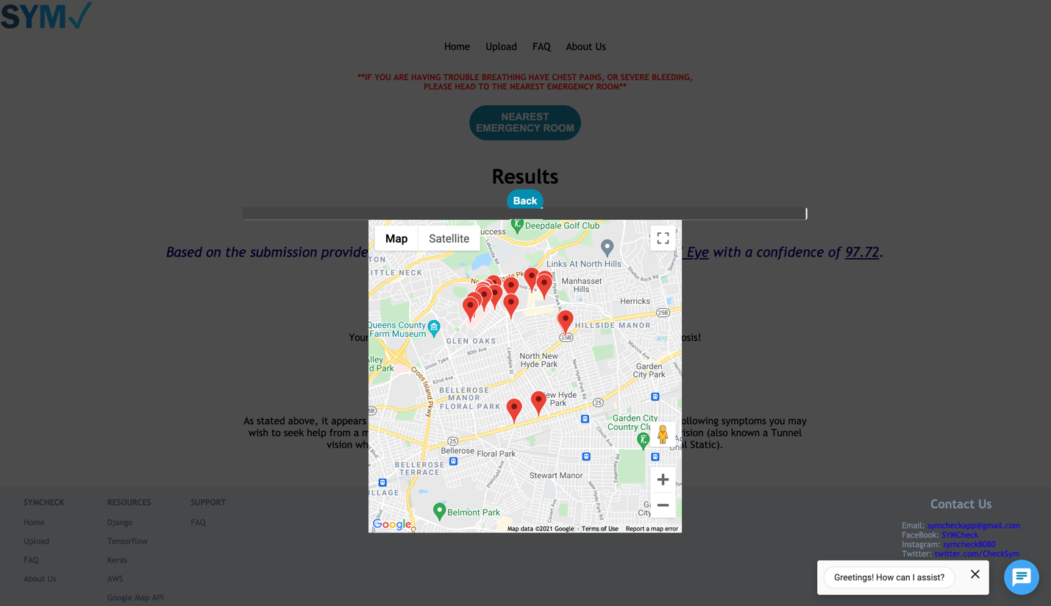

To close this map pop-up, simply press the “Back” button shown above the map itself.

**FAQ Page**

In the event that you have any questions regarding the SymCheck application at any time, or simply wish to view other patients’ popular questions or concerns, you can navigate to SymCheck’s Frequently Asked Questions or FAQ page as shown below:

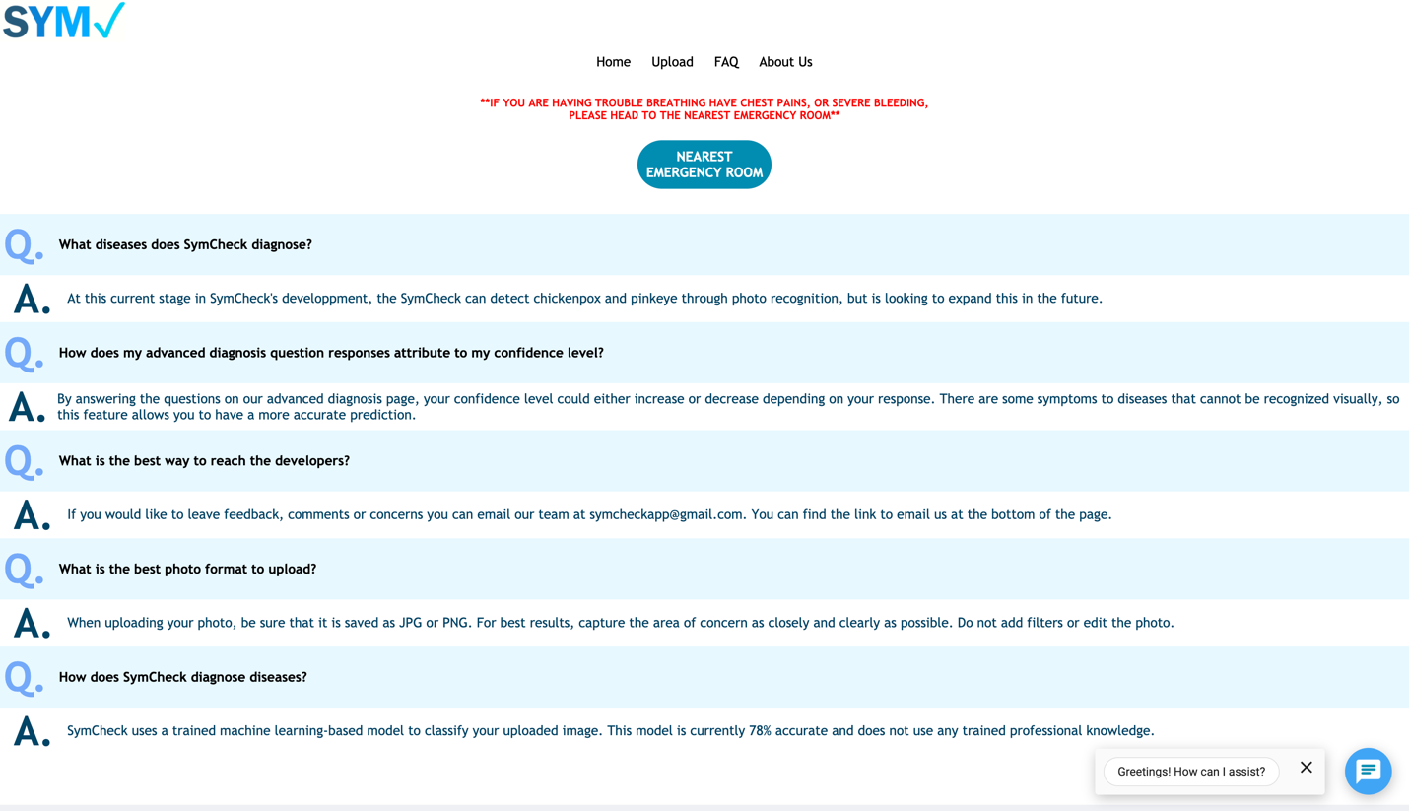

On this page, you will find and be able to peruse a list of those questions posed to our site and its developers often, dealing with anything from what illnesses are diagnosed/checked by our image-based classification algorithm, to how the application works.

**Nearest Emergency Room button**

If at any time whilst reading through the FAQ page you feel any of the symptoms outlined below, or deem your illness/ailment life threatening in any way, click on the “Nearest Emergency Room” button:



This will open a dynamic Google Maps window within the SymCheck application, showing you the locations of all healthcare facilities nearest you.

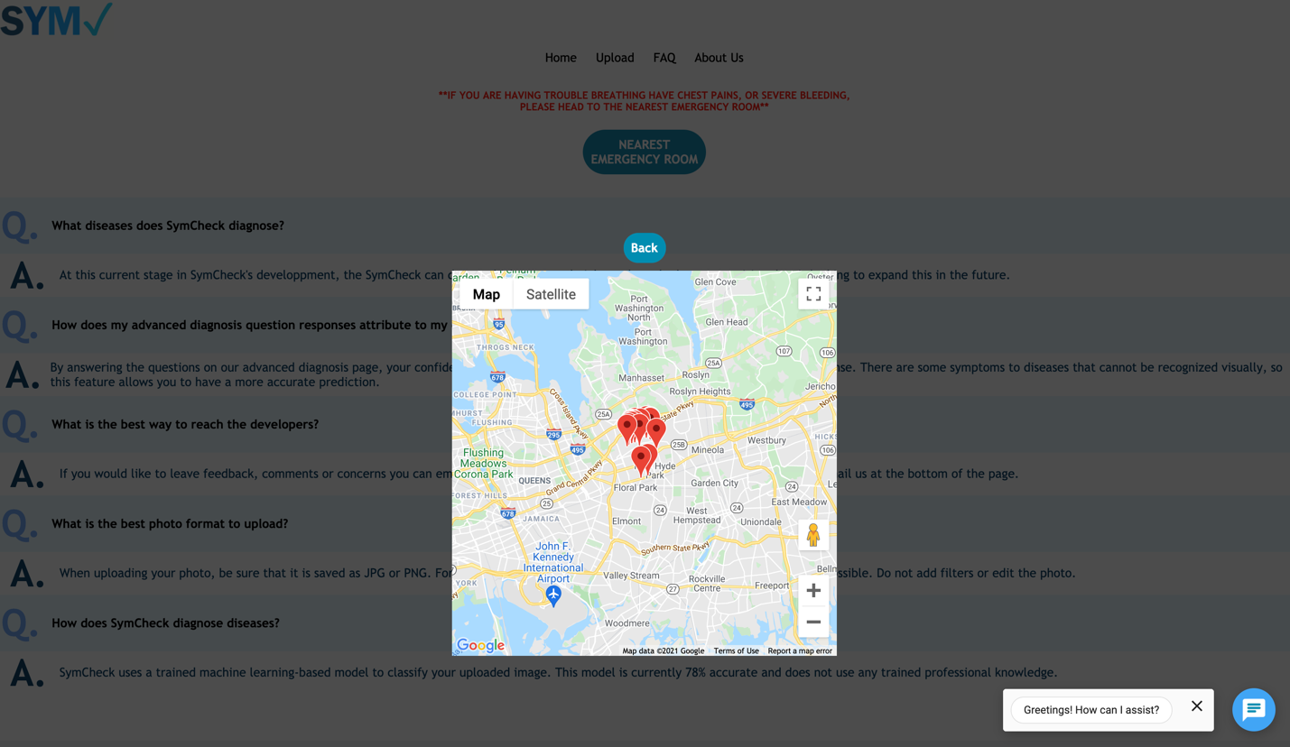

To close this map pop-up, simply press the “Back” button shown above the map itself.

**About Us Page**

If you are curious in learning more about the team behind the novel SymCheck application, you can navigate to the About Us page using the top navigation bar as shown below, from any page on the site.

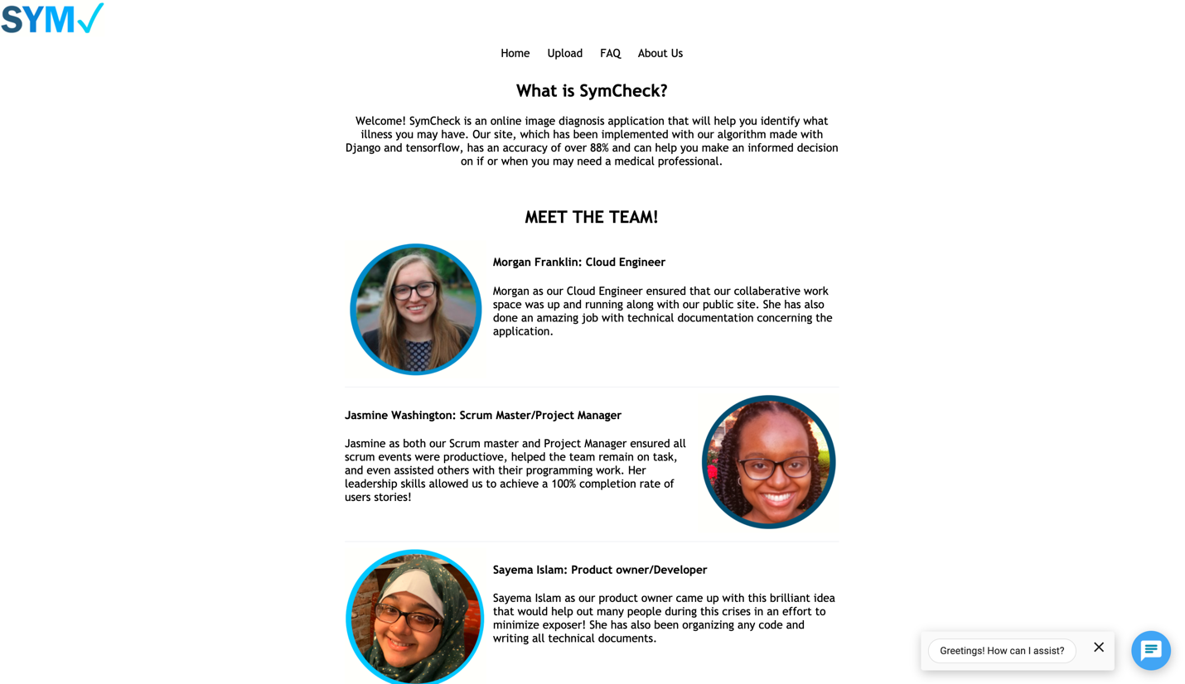

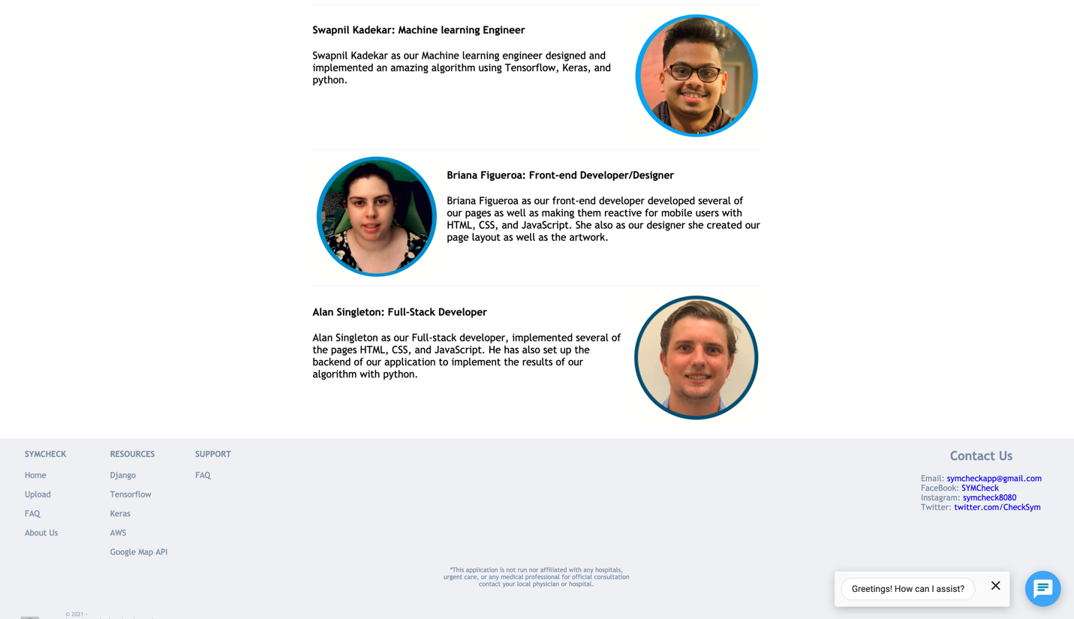

On this page you can read about the specific roles each member of the SymCheck plays in the development and maintenance of the application.

**Explanation of Sitewide Features**

**Site Navigation Bar**

Every page on the SymCheck application features the site’s top navigation bar as shown below:



Click on the links/tabs within said navigation bar to navigate to the four main pages of SymCheck, namely the Homepage, the image Upload page, the FAQ page, and the About Us page.

**Chatbot**

On every page on the SymCheck application you will have access to SymCheck’s live chatbot to which you will be, at any time, able to field any and all questions you may have regarding using the application, illnesses/ailments, contacting the team, etc. The chatbot can be found in the bottom right corner of every page as shown below:



The chatbot’s welcome message can be closed by simply clicking the “x” button, or clicking the chat icon itself, and can be toggled on and off respectively by repeatedly clicking the same icon again. Here is an example of the chatbot with the welcome message toggled off:

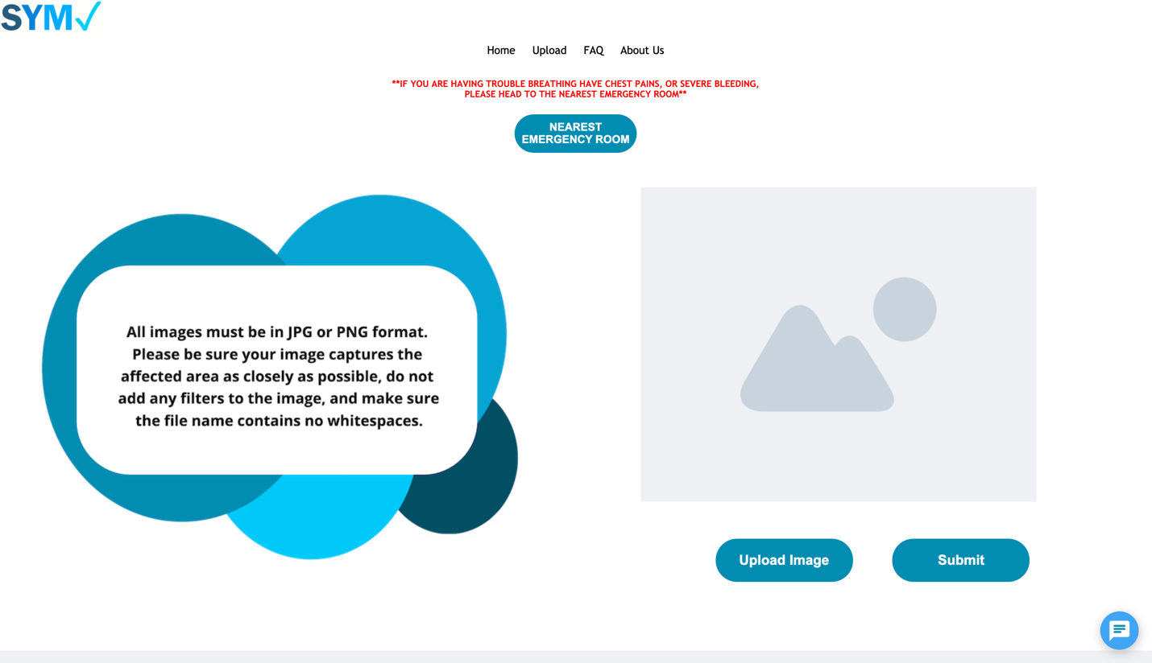

In order to open and use the chatbot in order to answer in questions you might have, simply click on the welcome message itself, and then type your question into the window. The chatbot will then answer your question with a series of pre-programmed responses it has at its disposal in its backend APIs utilized by the SymCheck application:

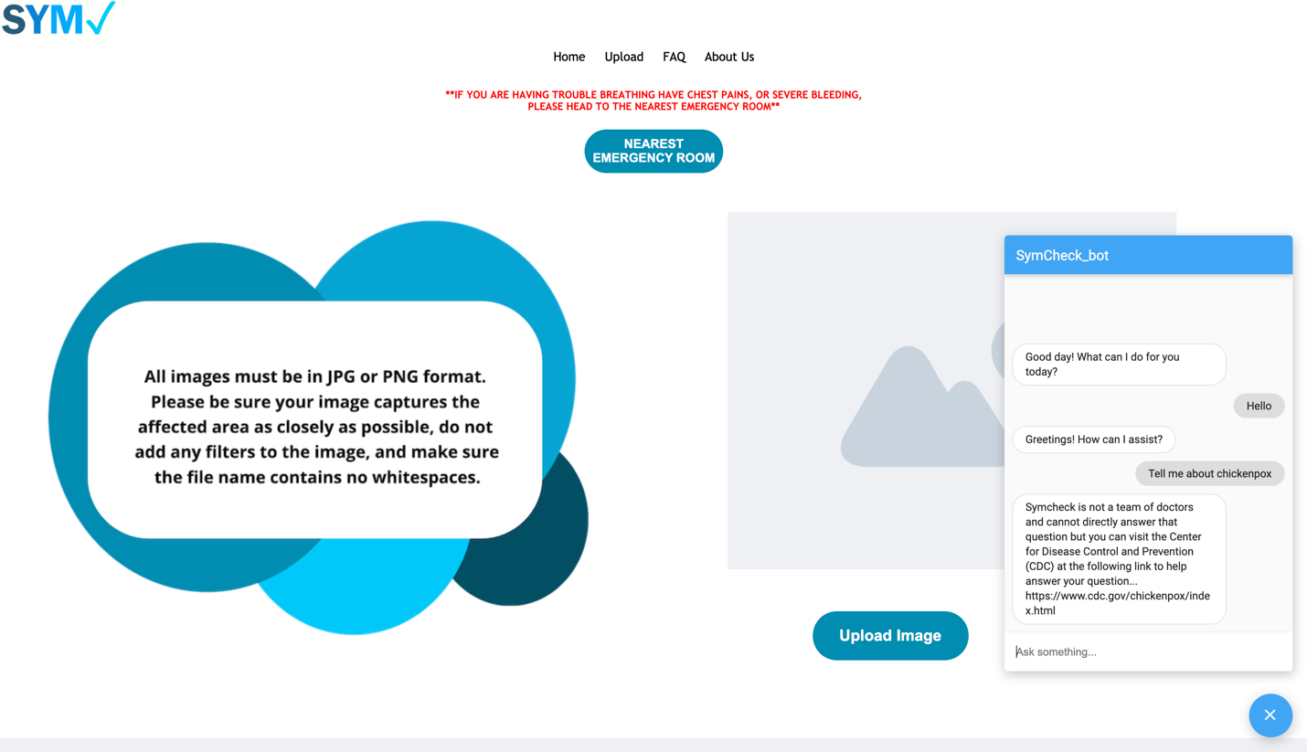

Simply click the “x” below the chat window when you are done to close the chat again.

**Site Footer and its Resources**

Every page within the SymCheck application features the same site footer with links to all the pages of the application (a functionality mirrored in the site’s top navigation bar):

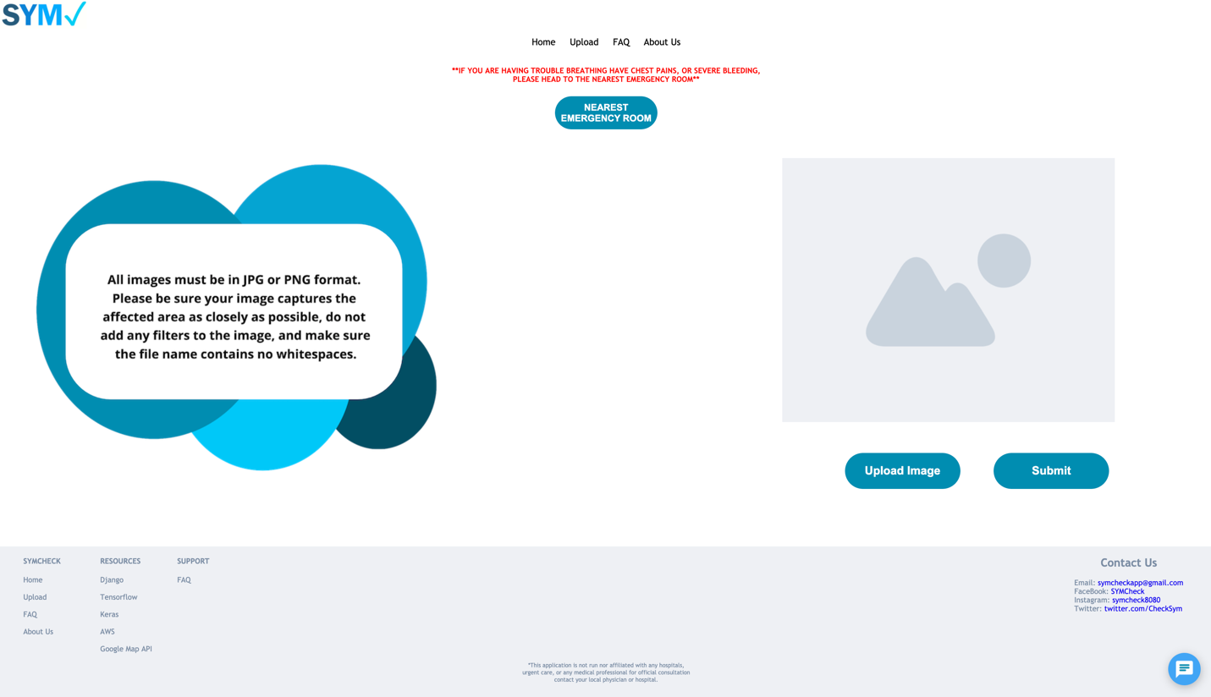

In this footer, you can also find links to various resources used to create, build, and run SymCheck for more information:



***Please note that clicking any of these links will take you to other websites, outside of the SymCheck application domain.

**Contacting the Team**

**Emailing the Team**

If at any time you wish to provide contact the team with any questions or concerns, or simply submit any suggestions or other feedback you have regarding the SymCheck application, you can email the team by clicking the email link found on the right portion of the page footer, as shown below:



This will prompt your browser to open an email window where you can then compose an email as you wish, to be submitted directly to a mailbox dedicated solely to the SymCheck application. Our team checks this mailbox daily on business days, so we’ll do our best to get back to you within 24-48 hours. We look forward to hearing from you!

**Social Media**

You can also learn more about and contact SymCheck through our various social media accounts, linked within the site footer as shown below:



Be sure to follow us to stay up-to-date on all things SymCheck!

|  |  |  |
| --- | --- | --- |
|  |  |  |